Answers:

HelloWorld + Time:

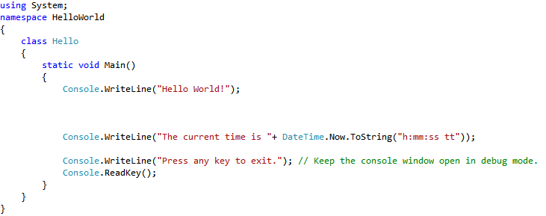

Loading a picture:

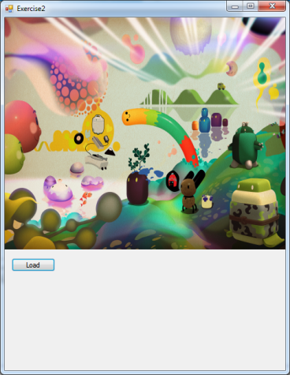 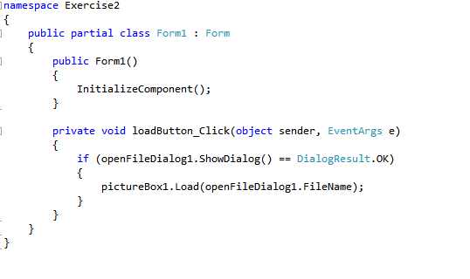

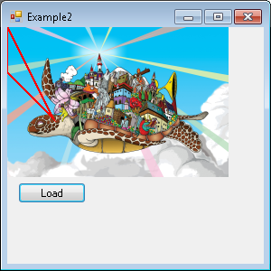Clicking regions in an image:

using System;

using System.Collections.Generic;

using System.ComponentModel;

using System.Data;

using System.Drawing;

using System.Linq;

using System.Text;

using System.Threading.Tasks;

using System.Windows.Forms;

using System.Drawing.Drawing2D;

namespace WindowsFormsApplication1

{

public partial class Form1 : Form

{

private GraphicsPath gp = new GraphicsPath();

public Form1()

{

InitializeComponent();

//Define any shape you like. Here just a triangle to test with.

gp.StartFigure();

gp.AddLine(0, 0, 0, 50);

gp.AddLine(0, 50, 50, 100);

gp.CloseFigure();

}

private void button1_Click(object sender, EventArgs e)

{

if (openFileDialog1.ShowDialog() == DialogResult.OK)

{

pictureBox1.Load(openFileDialog1.FileName);

}

}

private void pictureBox1_MouseClick(object sender, MouseEventArgs e)

{

if (new Rectangle(80, 30, 20, 20).Contains((e).Location))

{

MessageBox.Show("Clicked in a box!", "Mouse click detected");

}

else //polygon

if (gp.IsVisible(((MouseEventArgs)e).Location))

{

MessageBox.Show("Clicked inside polygon!", "Mouse click detected");

}

}

private void pictureBox1_Paint(object sender, PaintEventArgs e)

{

e.Graphics.DrawPath(new Pen(Color.Red, 2), gp);

}

}

}